

FEA Modeling for RF Cavity Windows

Muon Collider and Neutrino Factory Collaboration

MMAE Department

Prof. Gosz M.
Prof. Kaplan D.
Sharoa M.

I. Description of the test cavity

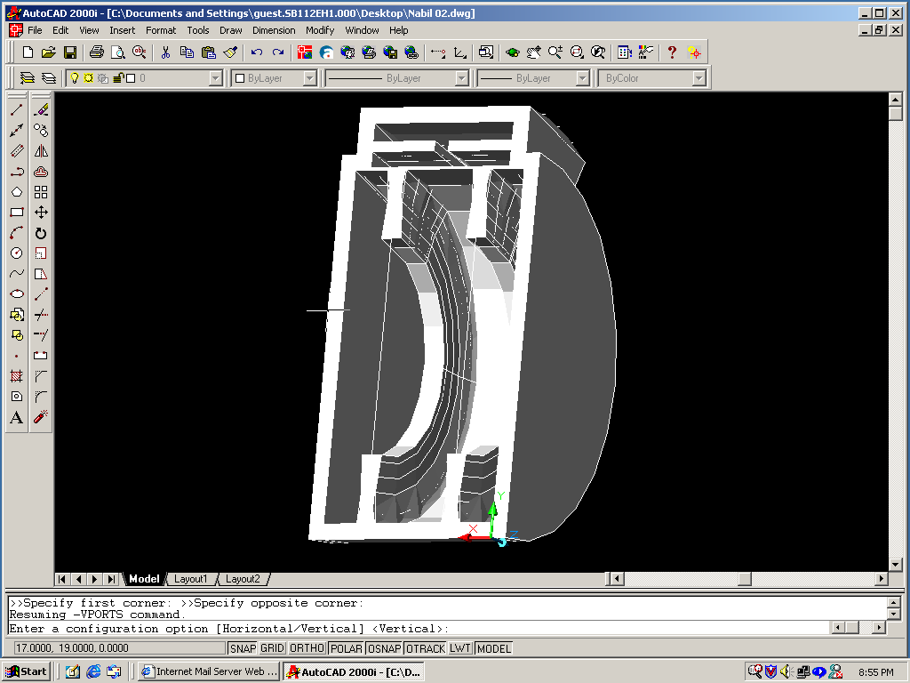

Fig. (1): 3-D model of the window and the test cavity

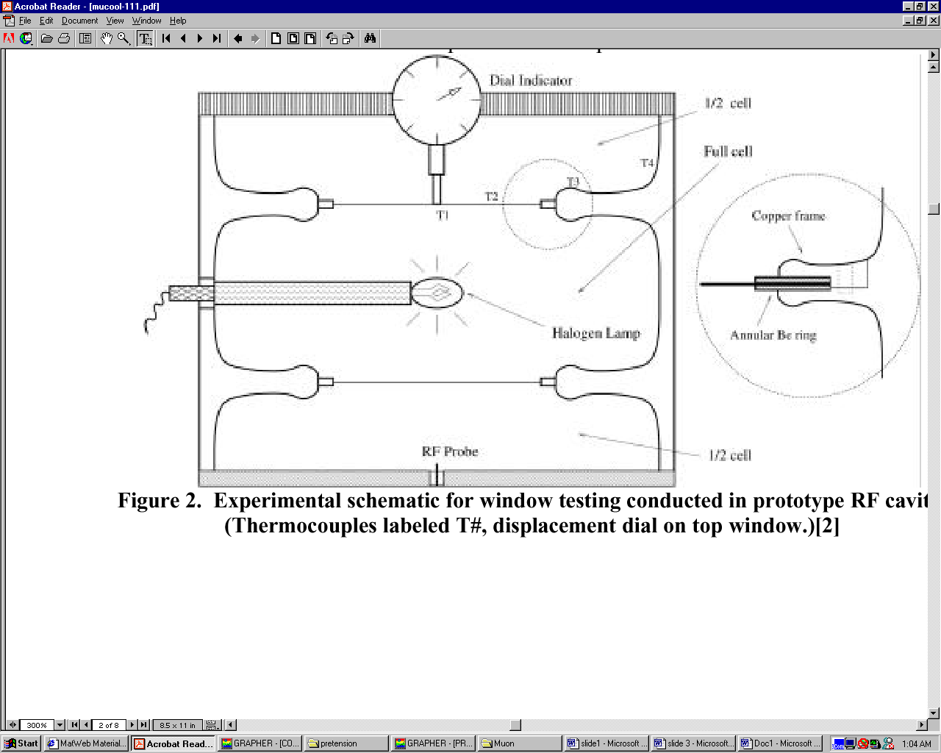

II. First Experiment Setup Lawrence Berkeley Lab. N. Hartman et al.

* AL Window, Radius = 8 cm, Thickness = 0.125 mm, AL Ring. No Pre-stress. Partially constrained window.

* The window is heated with a halogen bulb in a temperature-controlled enclosure, displacement was recorded as a function of foil radius, while the temperature was recorded with an infrared camera.

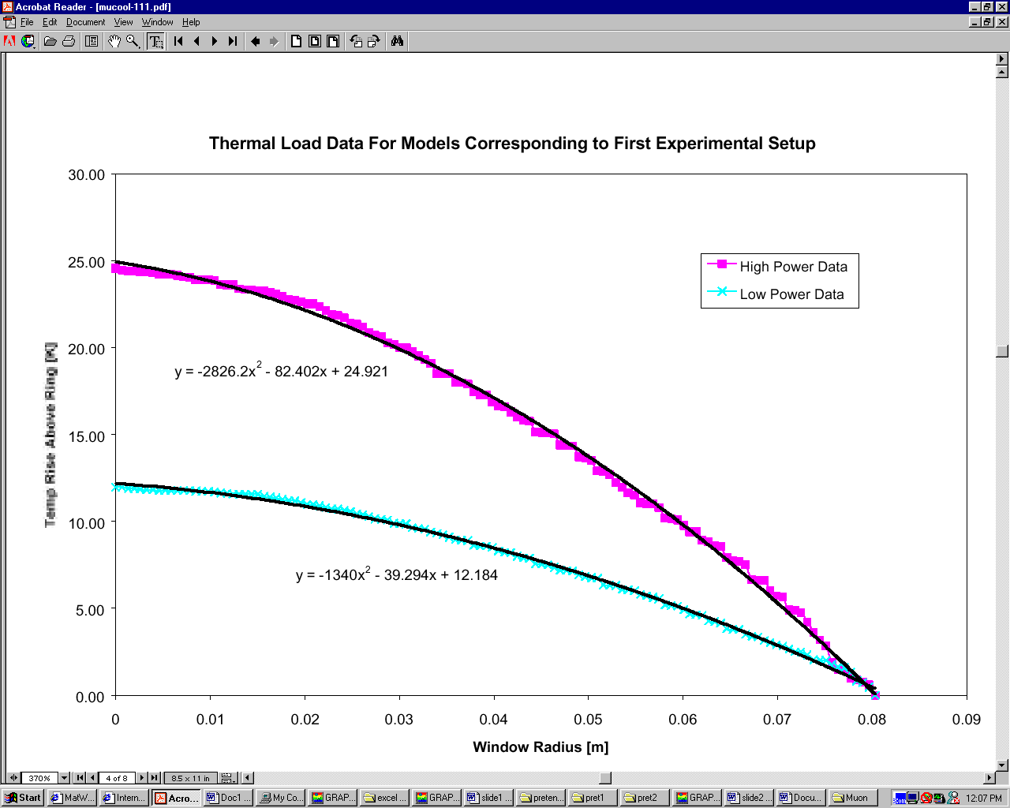

Fig. (3): Temperature loads for the two power settings on the halogen bulb in the first experiment setup.

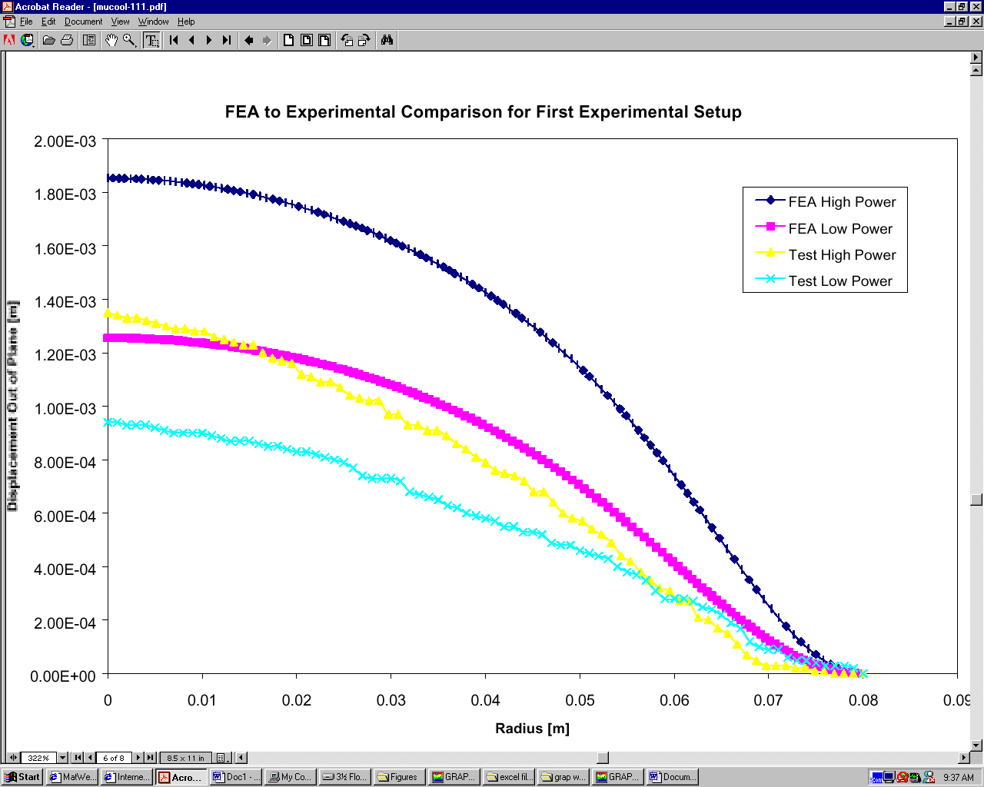

Fig. (4): Previous FEA to Experimental Comparison for AL Foil

Fig. (5): Present FEA to Experimental Comparison for AL Foil

Fig. (6): The displacement of the center of the Be foil is plotted as a function of the temperature rise using both experimental results and our present FEA results

* Tensile Yield Strength for Pure Be = 240 MPa

* Prediction was that the prestress = 50% * (Tensile Yield Strength) ~120 MPa

III. Conclusions

- Prestress is equivalent to the stress obtained by a temperature decrease of 29.04 K .

- Prestress = (126-128) MPa. Deviation from the prediction = (5.0%-6.0%).

- Prestress in the foil can be equivalent to the application of a temperature decrease gradient.

- Fundamental mechanical frequency of the “pre-stressed Be foil and the ring” under 0 temperature rise = 1281 HZ.

IV. Subjects Under Study:

* Effect of the temperature rise in the cavity body on the displacement of the foil.

* Comparison of experimental fundamental mechanical frequencies with those obtained numerically.

