Tests of Convective Heating of Liquids by Beams at the Argonne / CHM Linac
L. Bandura
NIU

Absorber Review

Fermilab
8/12/02

People Involved

ANL: Norem

IIT: Black, Cassel

NIU: Cummings, Bandura (master’s thesis)

U of I: Ducas, Errede
Introduction

Convection cooling vs. forced flow is a major decision.
- Significant impacts on design and cost

Calculations on both have been done, but not been experimentally checked.

An experimental test seems possible.

- We have seen beam-driven convective flow in water.

We can also obtain more than adequate beam power with the wide range of beam powers and densities available.

A Proof-of-Principle Experiment was done at the Argonne Chemistry Division Linac on June 13, 2002.

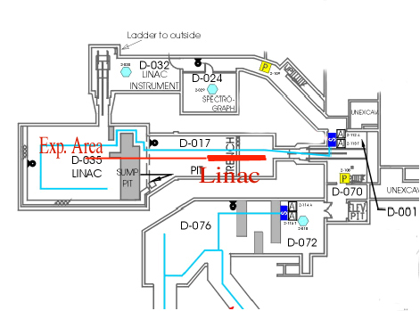

The linac can produce single bunches of about 30 nC at any rate up to 30 Hz, and multibunches at powers up to about a kW.

Access to the beam is easy, and control equipment can be set up nearby.

We operate as the only user when we run.

Proof-of-Principle Experiment

The elements of the system are shown below

The setup was in the linac beam after the final window.
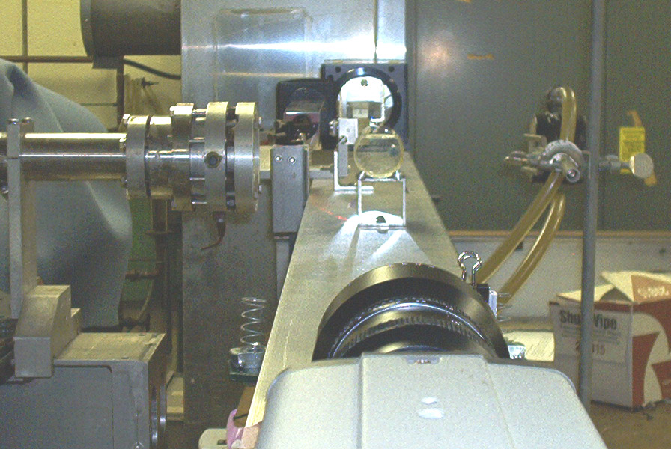

The sensitivity is determined by the response to 10 J of deposited power. This produced a clear signal. Much higher powers were available.
Results

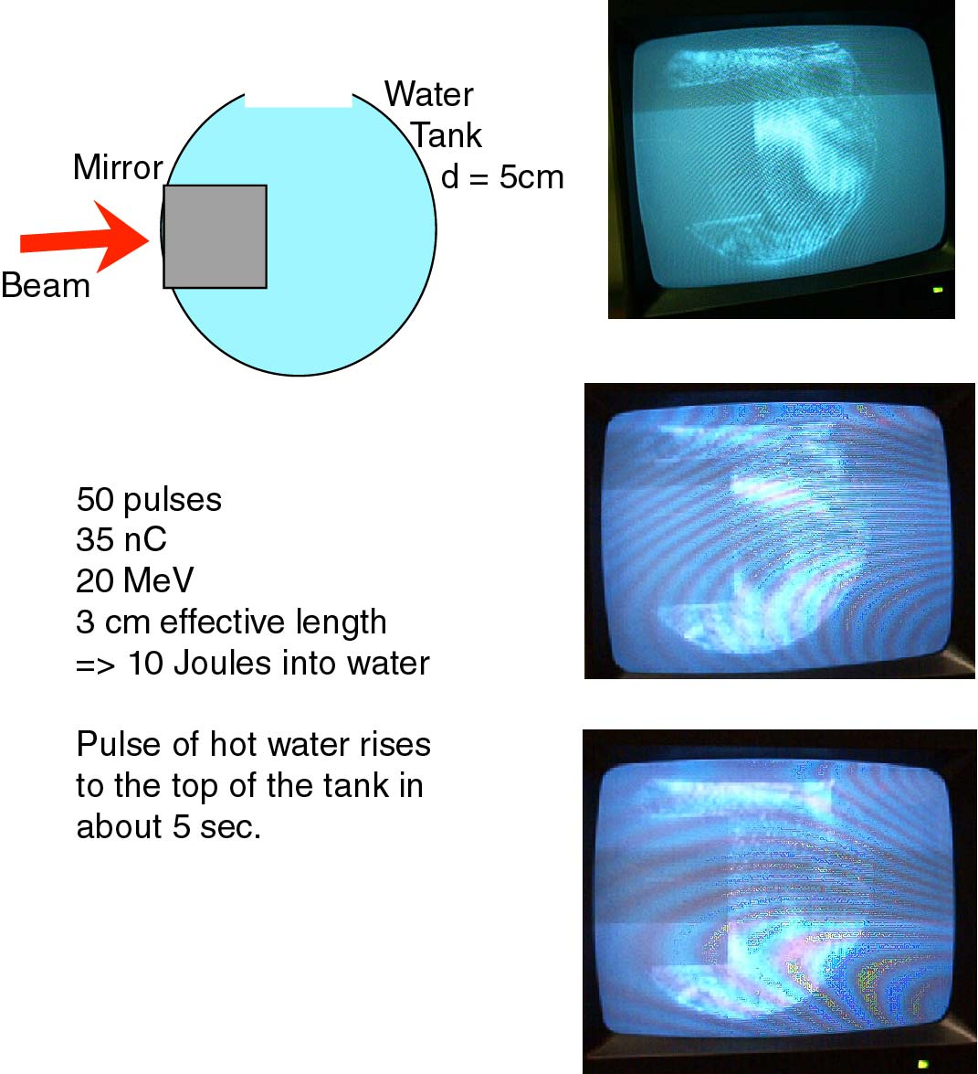

A Possible Experimental Setup

A number of cameras could be useful and more than one can take data at one time.
- Standard CCTV
- PIXCI still camera from EPIX, INC
- Movie camera

Cryogenic fluids such as LN₂ could also be used but would require thermal isolation from the long optical path.

We are setting up an experiment that can measure water, but will also be even more sensitive to cryogenic fluids.

A Schlieren system is more sensitive to fluctuations in hydrogen than water since the density and refractive index change more per degree of temperature.

LH₂ H₂O

n 1.109 1.33
(dρ/dT)/ρ 0.0152 -0.00023

Ronchi Measusrements

Quantitative measurements can be made with the Ronchi system.
- Works either with refractive or reflective perturbations

The grid target produces a pattern of bands across the image, which can be used to measure the deflection.

Status

Proof-of-principle experiment worked well.

Modifications to optics underway:

- The new water tank will be larger.

- Beam entrance and exit will be visible.

- The glass windows were tested and found to be not flat enough. (Argonne optics shop is repolishing.)

- We are rebuilding a shorter channel with different optics.

- A spatial filter should give a better image.

- Better cameras will be used.

We expect to run in the last two weeks of August with initial data on:

- Convection as a function of deposited energy density

- Friction effects near the window
Summary

- Beam driven convection can be fairly easily studied experimentally.

- Improvements in the system are underway and should produce better data in the next few weeks.

- Different optics, cryogenic fluids, and higher beam powers can give more quantitatively precise measurements.

